Tahera begum

2020-01-13

Bingo

Overview

Bingo is a game for fun played between two players. They both will have their own math board. There will be two dice that will be rolled. If the number rolled matches the answer of one of the equations on the player’s board, they get to fill in that square. The first player to fill in their board completely wins the game.

User’s Perspective

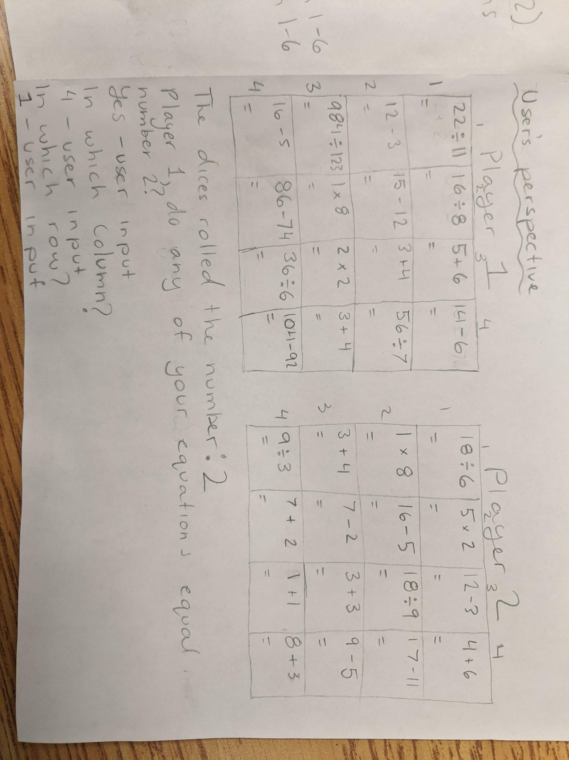

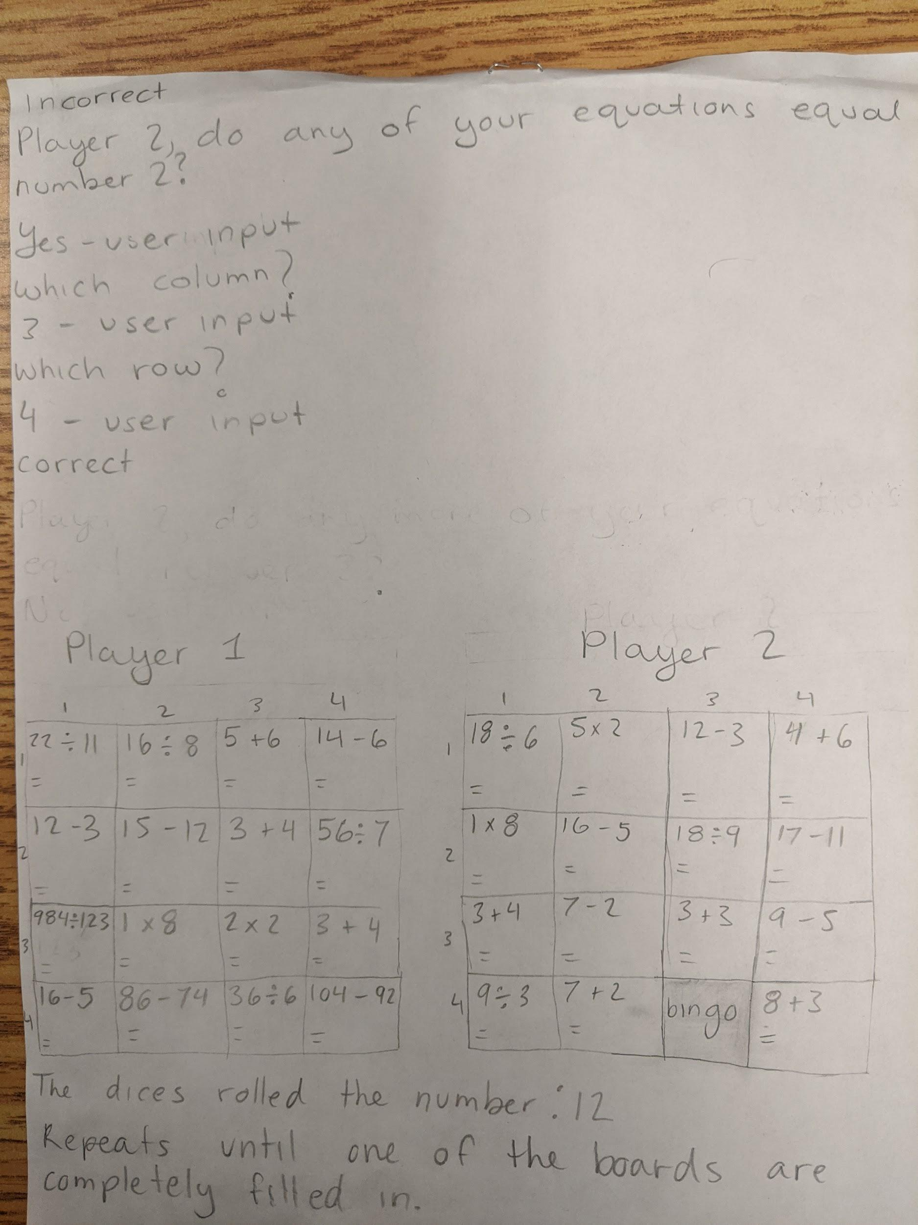

Methods

public static String equations1(String [][] arrEqua1)

* Stores all the math equations into the array for player 1

public static String equations2(String [][] arrEqua2)

* Stores all the math equations into the array for player 2

public static int answers1(int [][] arrAns1)

* Stores all the answers of the equations into the array for player 1

public static int answers2(int [][] arrAns2)

* Stores all the answers of the equations into the array for player 2

Main Method

for(;;)

{

Int die 1 = randomly generated # from 1-6

Int die 2 = randomly generated # from 1-6

Dice rolled = die1 + die 2

Println (how much the dice rolled)

String [][] equa1 = new String [4][4]

Send it to method equations1

String [][] equa2 = new String [4][4]

Send it to method equations2

Int [][] ans1 = new int [4][4]

Send it to method answers1

Int [][] ans2 = new int [4][4]

Send it to method answers2

//prints board for player 1

for (int row = 0; row <equa1.length; row++)

{

for (int col = 0; col < equa1[row].length; col++)

{

print(the horizontal lines of the board)

}

println()

println(the horizontal lines of the board)

}

println(ask player 1 if their equations equal to what the dice rolled)

If (user input is yes)

{

println(which column)

Int col1 = scan

println(which row)

Int row1 = scan

If (ans1 [col1][row1] = dice rolled)

{

println(correct)

Equa1 [col1][row1] = ‘bingo’

If ( player 1 board’s squares are all bingo)

{

println(player 1 won)

Break;

}

}

else

{

println(incorrect)

}

//prints board for player 2

for (int row = 0; row < equa2.length; row++)

{

for (int col = 0; col < equa2[row].length; col++)

{

print(the horizontal lines of the board)

}

println()

println(the horizontal lines of the board)

}

println(ask player 2 if their equations equal to what the dice rolled)

If (user input is yes)

{

println(which column)

Int col2 = scan

println(which row)

Int row2 = scan

If (ans1 [col2][row2] = dice rolled)

{

println(correct)

Equa1 [col2][row2] = ‘bingo’

{

println(incorrect)

}

If ( player 2 board’s squares are all bingo)

{

println(player 2 won)

Break;

}